**4 STAGE PIPE LINING:**

counter=1

a=int(input("ENTER NUMBER-1-"))

counter=counter+1

b=int(input("ENTER NUMBER-2-"))

counter=counter+1

printf("1-ADDITION 2-SUBTRACTION 3-MULTIPLICATION 4-DIVISION")

printf("Enter Your Choice")

choice=int(input())

if choice==1:

printf("Performing Addition...")

res=a+b

counter=counter+1

if choice==2:

printf("Performing Subtraction...")

res=a-b

counter=counter+1

if choice==3:

printf("Performing Multiplication")

res=a*b

counter=counter+1

if choice==4:

if b==0:

printf("Denominator can't be Zero")

printf("Performing Division")

res=a/b

counter=counter+1

if choice>=5:

printf("Enter Correct Input")

print(res)

counter=counter+3

printf("CYCLE VALUE IS:",counter)

ins=int(input("Enter the No.of instructions:"))

performance_measure =ins/counter

printf("performance measure is:",performance_measure)

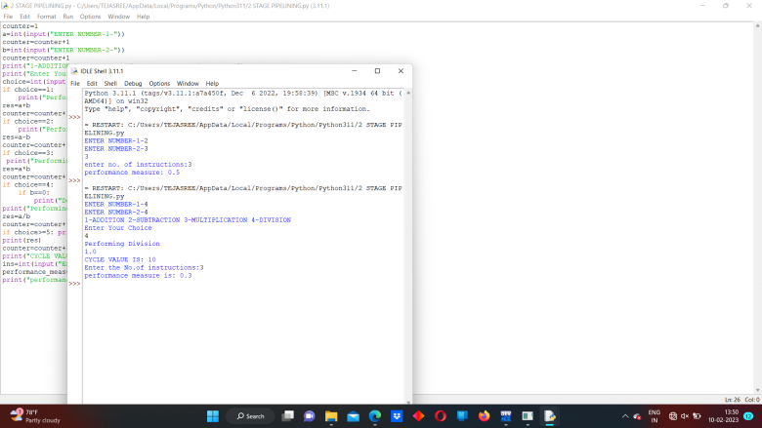ssssss